Electronic Supplementary Information

Limitations on the Use of UV/Vis Spectroscopy for the Evaluation of Conjugation Effectiveness

Nicolle N. P. Moonen and François Diederich*

Laboratorium für Organische Chemie, ETH-Hönggerberg, HCI, CH-8093 Zürich, Switzerland. Email: diederich@org.chem.ethz.ch

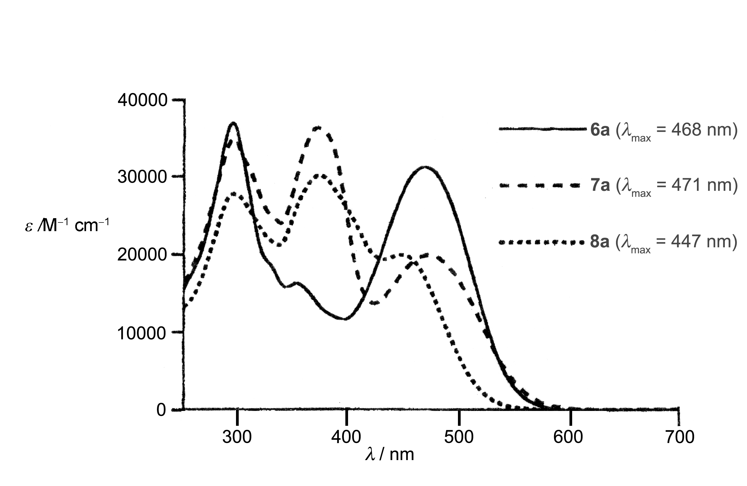
Figure 1ESI. UV/Vis spectra of 6a-8a, measured in CHCl₃. Figure adapted from reference 1 (ESI).

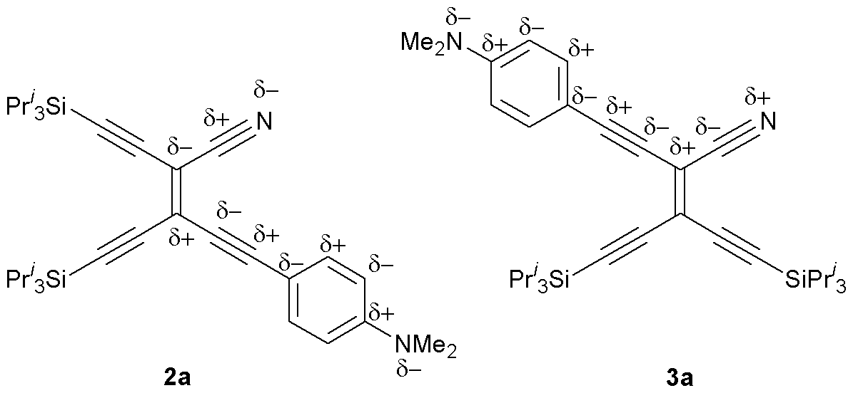

Figure 2ESI Principle of charge alternation, placing an unfavourable partial positive charge on the nitrile nitrogen of 3a.
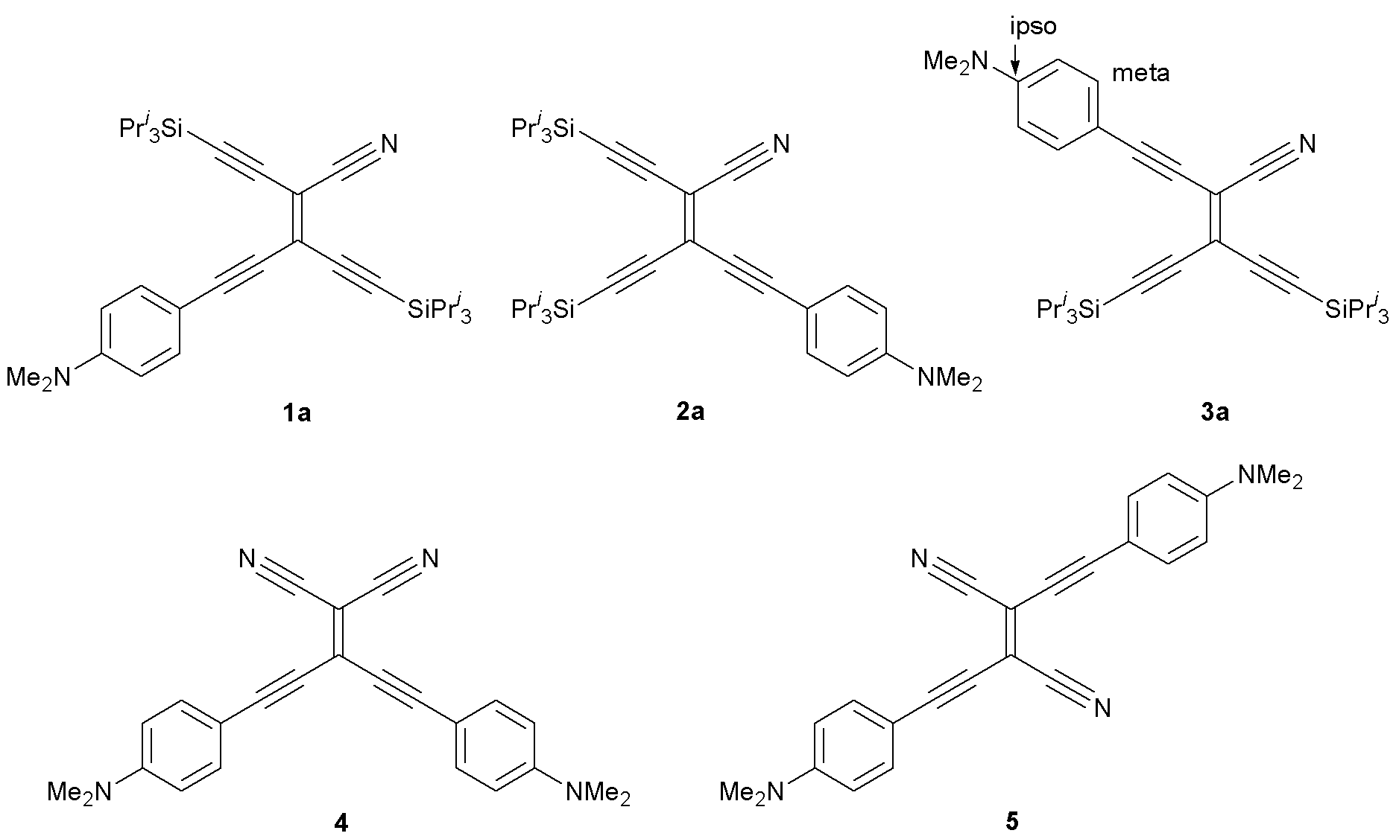

Table 1ESI. ¹³C-NMR shifts (75 MHz, CDCl₃) of donor-substituted CEEs. Chemical shifts (δ) are indicated in ppm downfield from SiMe₄, using chloroform’s residual signal as an internal reference.

Compound | δ_{ipso} | δ_{meta}
1a | 151.06 | 133.79
2a | 151.14 | 133.95
3a | 150.95 | 133.37
4 | 151.98 | 135.03
5 | 151.42 | 133.93

Table 2ESI. Experimental electronic transitions for the donor-substituted CEEs, derived from the UV/Vis spectra (of the silyl-protected analogues), and computed values, based on the TDFT-B3LYP/6-31G**//B3LYP/6-31G** method. CI = configuration interaction; H = HOMO; L = LUMO.

 | Experimental |  | Computed Values
Compound | CHCl₃  λ /nm | Hexane  λ /nm | λ/nm | E_{gap}/eV | f /M/Debye | Composition of band/  CI coefficients
1 | 464  338 | 448  329 | 443  327 | 2.80  3.80 | 0.76/8.46  0.23/3.99 | H−1 → L  H → L  H−1 → L  H → L+2 | 0.13  0.62  0.61  0.20
2 | 467  328 | 453  327 | 453  327 | 2.74  3.80 | 0.78/8.68  0.23/4.01 | H−1 → L  H → L  H−1 → L  H → L+1 | 0.13  0.62  0.61  0.19
3 | 470  324ª | 458  317^{b} | 458  325 | 2.71  3.82 | 0.77/8.66  0.24/4.08 | H−1 → L  H → L  H−1 → L  H → L+1 | 0.13  0.62  0.61  −0.22
4 | 524  -  - | 489  -  323ª | 480  442  323 | 2.59  2.81  3.84 | 1.03/10.26  0.40/6.15  0.14/3.15 | H−1 → L  H−2 → L  H → L  H−2 → L  H−1 → L+1  H → L+4 | 0.66  0.10  0.62  0.63  0.18  0.11
5 | 563  325ª | 524  313 | 547  329 | 2.27  3.77 | 1.50/13.22  0.16/3.32 | H → L  H−2 → L  H−1 → L+1  H → L+2 | 0.61  0.62  −0.10  0.22
ª shoulder.
^{b} additional shoulder at 324 nm.

Reference:
1 R. R. Tykwinski, M. Schreiber, V. Gramlich, P. Seiler and F. Diederich, Adv. Mat., 1996, 8, 226-231.

